Challenges
to Deploying and
Managing the Cloud
Now…

“A Perspective on Ways of Forward Managing IT”

A white paper by


Challenges to Deploying and Managing the Cloud Now…

You’ve no doubt already read in at least ten whitepapers that moving to the cloud will solve all your IT problems. Once everything is virtualized, you’ll have no physical equipment to worry about.
“There’s more about transitioning to cloud computing than most people are talking about. Because what you can’t see and measure, you can’t manage.” ??

Further,
- Everyone will love you every time you walk through the office
- The Old Spice guy will want to smell like you
- Barney from “How I Met Your Mother” will use your name in
place of the word “awesome” forevermore

- The cloud will do everything and manage itself
Of course, this isn’t exactly the case. What’s worse is even though you know better, there’s a good chance your boss or the hungry-for-IT-as-an-infrastructure crowd in your organization thinks these things are actually true and the impatient foot-stomping sounds of “is it done yet?” are reverberating through the halls by day and in your head at night.
The promise of the cloud certainly offers many potential advantages. It can provide greater resource efficiency, power savings, real estate benefits, and most of all it can save a tremendous amount of money. However, if the IT infrastructure in an organization is not also managed through the methodical application of best Service Management practices, migration to the cloud will both increase IT overhead as well as headaches.

Ballooning IT Complexity
Information technology is no longer limited to discrete devices, nor is its use limited to highly trained people. Instead it is found throughout the business. Where the technology itself was once the centrepiece, now creation and management of information dominates in business. Information permeates virtually every business process. Even procurements and ordering janitorial supplies is inventoried and monitored by some database.
The ivory tower has been depopulated and IT has been scattered throughout the business. Ask yourself:
- Where is the data and information generated in your business?
- Who is collecting the data?
- How is it being used?
- Who manages and maintains the equipment?
- Does IT even have direct responsibility over all assets with embedded IT technology?
- What about other common assets in the company such as office and cubicle assignments?
If the IT help desk is responsible for assigning, provisioning and maintaining the IT equipment given to an employee wouldn’t it make sense to integrate the assignment of non-IT assets through the same set of processes? That’s the topic of another story.
It’s these modern realities of computerized business management that dramatically increases the complexity of and demands on an IT service management organization. While adding new tools to a company’s IT toolbox is usually a good thing, it also adds more layers of complexity that have generally not been recognized. This white paper examines some of these new complexities while also reminding IT professionals to think of IT as a service and not just a conglomeration of technologies. Finally, it will discuss ways to strategically integrate IT with the rest of the business functions.

The Explosion in Business Devices

Recall the beginning of business computer use. In those days, a company may have had one computer and it is likely that only a few people actually knew how to use it. Fast-forward to the present and you have a situation where every employee in an organization has a computer. Not only do most employees have a personal desktop computer many likely also have a laptop, smart phone, and a tablet.

In early 2011, Forrester Research estimated that 24.1 million tablets would be sold in the United States in 2011. This is more than double the number sold the year before. Forrester estimated that the number would jump to 44 million by 2015 as shown in Figure 1.

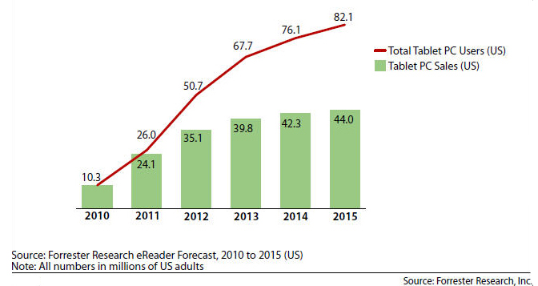

Figure 1. Forrester Research’s US Consumer Tablet forecast

(http://blogs.forrester.com/sarah_rotman_epps/11-01-04-us_tablet_sales_will_more_than_double_this_year)

While most tablets are used for personal activities such as web surfing, reading books, or watching videos, there is evidence that tablets are also infiltrating the business world. According to Deloitte, businesses will purchase 25 percent of the tablets sold in 2011 (see Figure 2).

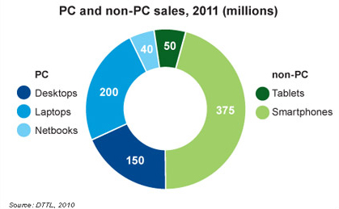

Figure 2. Deloitte’s computing device market forecast

(http://www.eweek.com/c/a/Desktops-and-Notebooks/Tablets-Smartphones-Fuel-10-Technology-Trends-for-2011-Deloitte-113531/)

These numbers are staggering, particularly since the tablet craze is still so new. The Apple iPad was launched less than two years ago.
Before the iPad came the iPhone and it triggered a smartphone explosion. A Microsoft Tag report claims that of the four billion mobile phones used worldwide, 1.07 billion are smartphones. This number is growing, especially in developed nations. The rise of smartphones and tablets also underscores another element, adding to IT management complexity. This is the blurring of lines between the personal and professional. Many people own their own smartphones or tablets, yet certainly expect to connect to the company network for work.
With the rise in knowledge work, performing it from a central location is decreasing. People can work from everywhere. Go to any Starbuck’s or Peet’s coffee shop for ample proof. Many power up their company laptops and log on to the network from home or elsewhere for email and to work on documents.
Information technology may also be found embedded in vehicle fleets, industrial equipment, office phones and more. These are all company assets and may require configuration, monitoring and management throughout their life span.
Being able to manage and provision services for such an array of devices is essential to the supporting any business. Doing so in an ad hoc, “whatever you desire” manner is a recipe for disaster, heartache and unemployment. The only sustainable solution is applying best IT Service Management practices—such as those document through the ITIL service library—and to implement them using a flexible and affordable tool set based on ITIL.

It’s All About the Service
In the midst of this growing array of new technology, it’s important to consider that the technology is not the star of the show anymore. The services provided through the use of the technology are what matters. IT provides and enables the services that ultimately allow a business to be successful. Businesses must provide its employees with the equipment they need in a short period of time. More importantly, they want to know that employees have a reliable ability to communicate with others.
The technology embedded in laptops and email is only a means to an end. In the case of the laptop, one end is creating documents. The most essential end with email is communicating with others quickly and easily. IT departments need to understand the ultimate purpose of the resources they provide is integrating their work within the larger business framework. The business client does not care how the services are provided as long as the results are achieved and however they are, will be more sustainable with repeatable processes.
There needs to be documented processes to produce outputs that are satisfactory to the business. For example, an employee who is working from home may be accessing a virtual machine but he still needs a laptop or other device to do so. These devices need to be managed and there must be a central repository of information so that the use of company assets is being tracked. One way to track assets is through a Configuration Management Database (CMDB) allowing IT to see what business assets are being used and their relationships to each other.
This may not seem like such a big deal, but think about all of the different types of devices that can be used. Multiply that across a thousand people or more working within a large organization and you will see the value in having a proven system to track all the assets and resources. An added component of many CMDBs is auto discovery, a tool that finds IT or other resources on a network and automatically adds them to the asset database.
Applying IT Insights
Once you have an idea of available IT resources, the business must know how to effectively use them. This includes documenting any issues that arise and troubleshooting them in a systematic way. This methodical strategy goes beyond the ad hoc approach that may have sufficed when systems were less complex. You could call on IT to come in and fix your computer and that would solve an immediate problem and allow you to return to work. However, if the issue wasn’t documented, the same problem could arise later and no one would know how to fix it.
This is why IT Service Management (ITSM) has incident and problem management. Incidents are smaller troubles that point to bigger problems. For example, if someone can’t log into their email account because Active Directory is not functioning properly. The inability to log into an email account is the incident and the non-functioning Active Directory is the problem. The first is the symptom and the second is the root cause.
Only by creating systematic records of issues as they arise can you effectively troubleshoot in a way that allows you to use what you learned in the future. Once incidents and problems have been identified and resolved, IT can create knowledge articles that cover all of the solutions. Knowledge management takes what has been learned and converts it into a body of knowledge that can be used in the future when similar issues arise. It also takes control out of the hands of a limited number of IT experts and places it into the hands of regular employees who can read the knowledge articles and solve their own problems, which is a very good thing for several obvious reasons.
Often, there will need to be major changes to a company’s software infrastructure. Change management ensures that these changes are carried out with a minimal amount of disruption to end users. A series of changes is known as a release and these too must be managed and documented so that the desired outcome can be reached in a minimum number of steps. If something should go wrong, it’s easy to go back to the written record and see what happened. The change and release management processes also provide complete clarity on who exactly is managing the changes and releases so that there are no overlapping efforts and so that people understand who is ultimately accountable for the modifications at individual stages of the process.

Future Insight
In addition to managing existing resources, issues that arise, and changes that need to be made, an IT department must also have a clear process for clients to request services. These may include asking for a laptop or other device. A service portfolio is a list of all of the services that an IT department offers. A redacted portfolio, or service catalogue, is available for each individual user. Some users will not have access to certain IT services based on their level within a company. For example, a user may not have permission to order a company cell phone. An employee can see which services he is entitled to and then request them through another process called fulfilment or request management.
At the highest level of a company, there are service level agreements between the IT provider and the customer. These agreements lay out detailed expectations for the provision of IT services. Not only are expectations clear, but there is also a way to track whether or not they are being met. For example, perhaps one of the agreements consists of a ceiling on the amount of time that IT should take to resolve a specific issue. There will be a mechanism in place to see how long the IT provider is taking on these tasks and both they and the customer will be alerted if it takes more than the allotted time.
Conclusion
It’s an exciting time for IT providers as there have never been so many ways of providing services to customers in amazingly cost-effective ways. The cloud opens up many new opportunities but it will ultimately disappoint everyone if there are not effective mechanisms in place to managing it. ITSM and ITIL both provide a recognized framework for overseeing IT processes and outputs. While it may be easy to get bogged down in the terminology, it is important to remember the end goal. This is increased productivity at the lowest costs possible. Investing in a well-integrated system will allow companies to realize financial benefits because they truly understand IT investments and exactly how those resources are being managed. Knowledge is always the key to making better decisions and to using financial resources wisely.
For more information, visit www.bluehawknetworks.com.
ITIL® is a registered trademark and a community trademark of the Office of Government Commerce, and is registered in the U.S. Patent and Trademark Office.
Copyright 2011 – Bluehawk Networks Inc.

